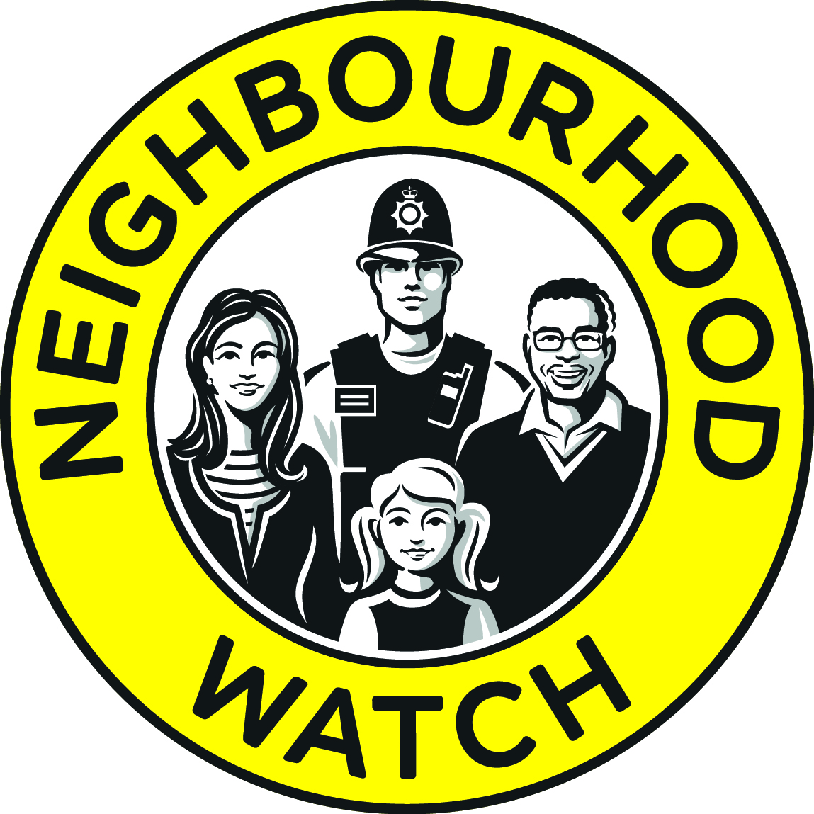
East Riding
Neighbourhood Watch
Association
April 2011

Neighbourhood Watch: East Riding of Yorkshire Council: For Town and Parish Councils

The Role:

To be the main point of contact for Neighbourhood Watch on behalf of East Riding Council/Humberside Police and the residents.

To have Neighbourhood Watch and crime resilience as a regular item on your meeting agendas.

To receive and forward on any crime prevention alerts and crime resilience information from East Riding Council/Humberside Police to the residents via newsletters, websites and/or Facebook pages.

To help East Riding Council/Humberside Police to encourage and empower residents to report crime and share anything they have reported to the Police with their neighbours and the Parish Council.

To help East Riding Council/Humberside Police to encourage residents to report crime and keep the police informed of any activity that they think is suspicious.

Aims:

To increase community engagement in the prevention and detection of crime

To promote interaction and public awareness through Neighbourhood Watch

To help increase community safety and reduce the fear of crime

To improve communication between residents Humberside Police and East riding of Yorkshire Council

The Advantages:

Crime resilience information and crime updates from East Riding Council and Humberside Police

Information and support on how to register on Immobilise and My Community Alert

Improved communication and promote reporting crime

Direct links to your Police Community Safety Officers (PCSO)

Fee NHW street signs and window stickers to send out a clear visual message

Links with other partners such as Trading Standards, Humberside Fire Service and Age UK

Notification of any relevant funding grants for home security items for the residents.

Support from East Riding Council/Humberside Police and the local area/district groups to give the residents a bigger voice regarding crime and other issues in the area

Signposting on other issues such as flytipping and dog fouling.

Increased sense of community well-being

