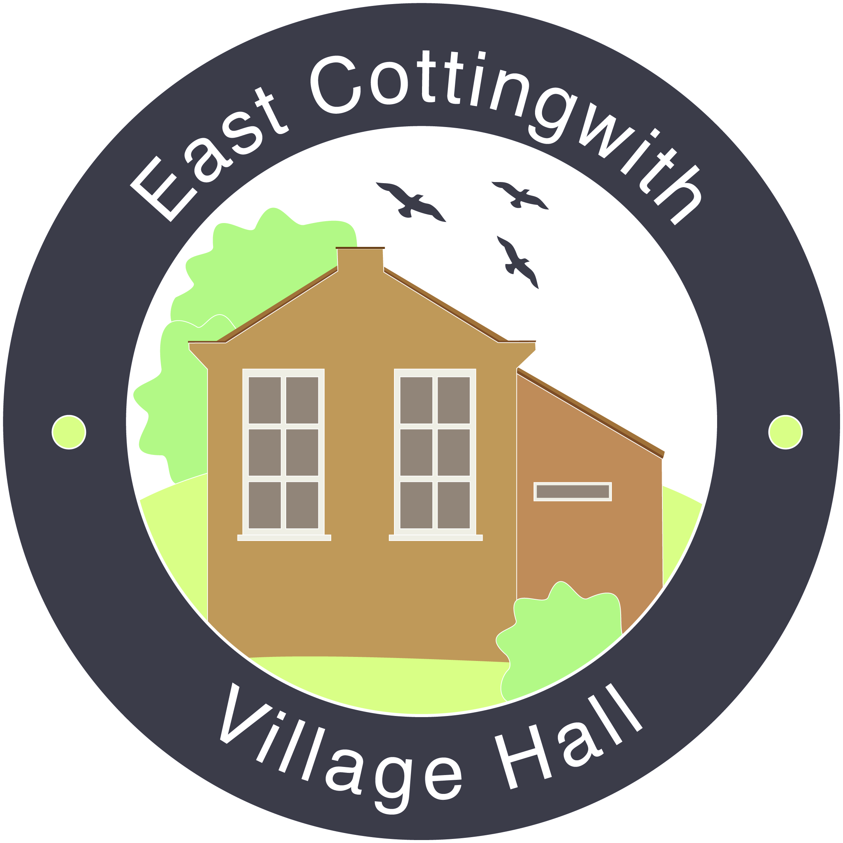

East Cottingwith Village Hall Newsletter 2018/2019

Dear Villagers

We would like to thank everyone who has supported the village hall over the last 12 months through, amongst other things, bookings, donations, attending events, helping at events and buying tickets for the village draw.

We have been busy! Highlights include:

- the village brunch: so many of you joined us and contributed to the formulation of our plans for the future of the village hall. Thank you! We have used the last few months to incorporate as many of your ideas as we can into planning extensive renovations for the hall. So far, we have new blinds, which have been very well received. We have now agreed some plans with a local architect, which we intend to take to planning soon. Once plans have been approved, we will be working hard to ensure funding through grant applications and general fundraising events in order to bring those plans to fruition. A copy of the plans is displayed on the village notice board by the bus stop and will also be posted on the village website: http://www.eastcottingwith.org.uk.

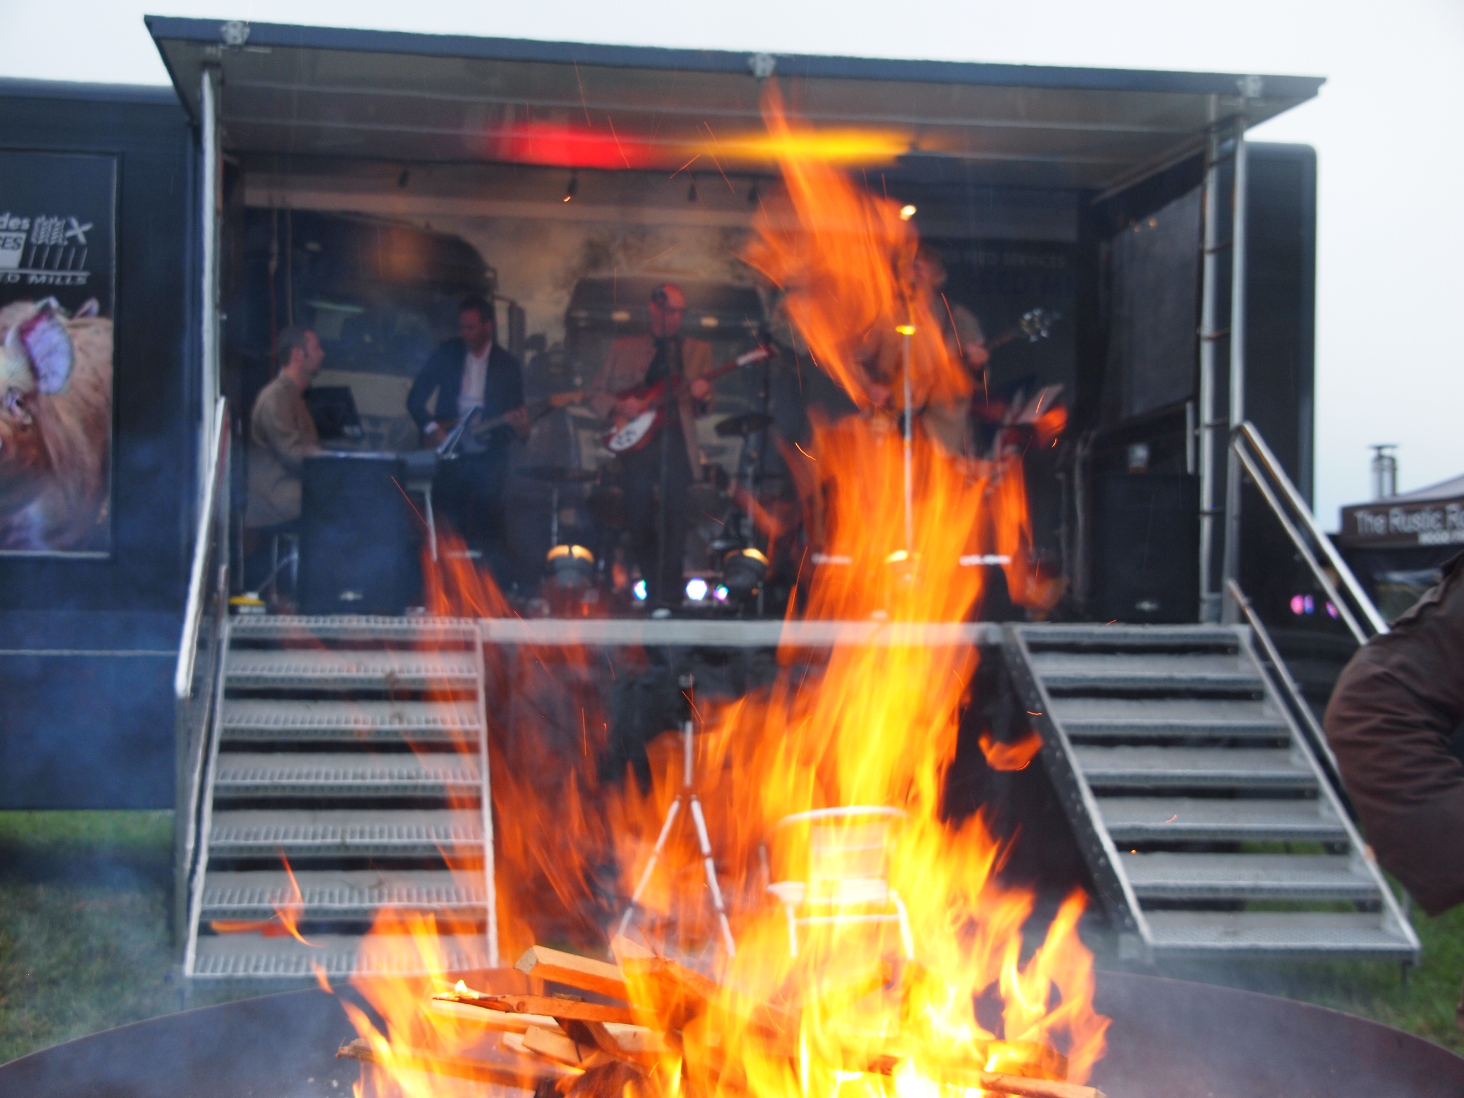

- the village fete: this was an amazing success, in spite of the weather. The hall was used for toilets and refuge from the rain! The fete committee donated 50% of the takings to the hall (£608) and Dave Shaw donated £250 from the bar takings. Thanks once again to the fete organisers.

- Mikron: the Mikron Theatre came to us again in October. The hall was packed out with both locals and non-locals. The raffle and refreshments raised £110 for the hall.
- the World War 1 commemorations: the hall looked amazing, decorated in poppies knitted by you and your families, and provided a great venue for showing all your WW1 memorabilia. Your family archives were fascinating. The commemoration organisers donated £100 towards our funds – thank you once again!

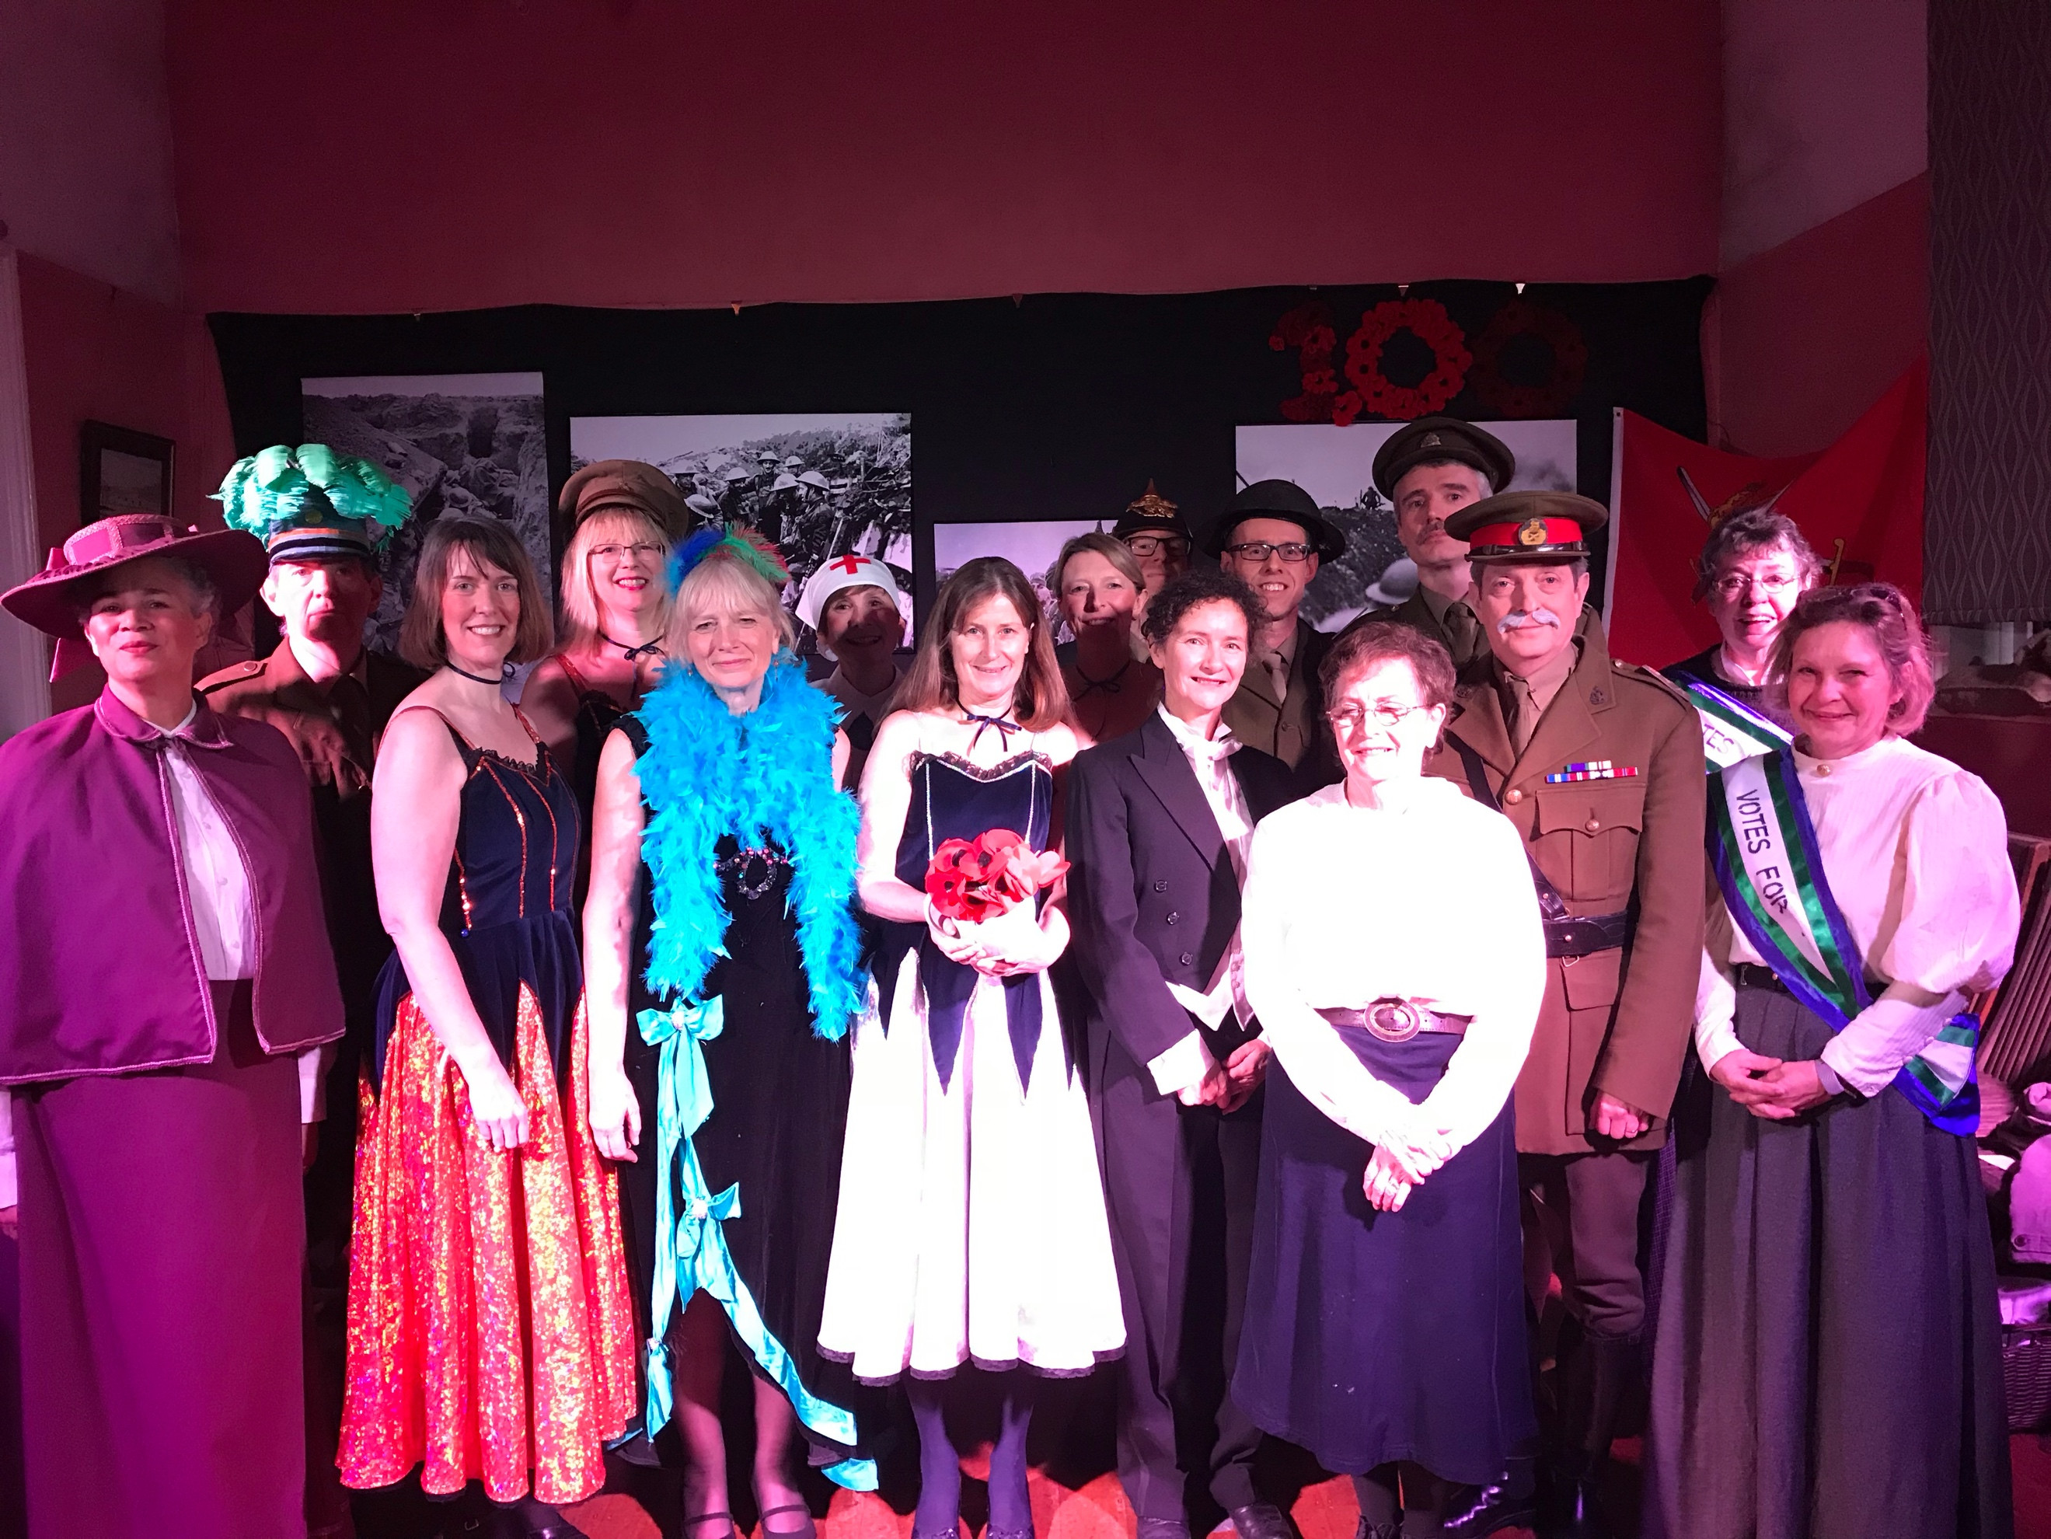
- Oh What A Lovely War!: for two nights in November the hall was magically transformed into the trenches of WW1 and we were entertained, educated and touched by the East Cottingwith Players’ production. Thanks to all who were involved at every stage of the show, and to everyone who came to support it. An amazing £842.50 was raised for the village hall.

We hope that 2019/20 will be just as busy and would love to hear from anyone who has any ideas for future events. Current thoughts include a launch event for our fundraising (curry night?), dancing with Smithy the milkman and a music café.

Village Draw
Now that winter is coming to an end, it is time for us to collect money for the village draw once again. Tickets work out at just 50p each month and we can collect 6 monthly (£3) or annually (£6). Should you wish to purchase tickets, please fill in the sticker on the front of your envelope, pop the money inside and either give to one of our trustees (see below) or drop off at Sycamore House on Main Street (opposite the bus stop). The new draw year starts in March, so please ensure that your tickets are purchased by the end of February. The prizes each month are 1st: £20, 2nd: £10 and 3rd – 5th: £5. Last year the draw raised over £400 for the hall, after deduction of prize money. Last year’s winning tickets are listed at the end of the newsletter. In future, winners’ names will be published monthly on the village notice board and website.

The money raised from the draw, together with money from bookings, fundraising and donations is used for the general upkeep of the hall. The cost of insurance, heating oil, electrical and other checks and bills all add up over the year, and we could not keep up with those bills without your help. In addition, as mentioned above, we have plans for renovations and improvements of the hall. The drawing up of plans and the planning process will also come at some cost although our architect has offered us favourable rates. We have some money already put aside and we will soon be able to look for grants and funding for the renovations. The more the hall is used, the better our chance of securing funds, so please do remember us when planning parties, clubs, meetings and other events. Our rates are £6 per hour for villagers (which includes use of the kitchen).

A copy of the accounts is displayed on the village notice board by the bus stop and will also be posted on the village website http://www.eastcottingwith.org.uk.

Thank you to everyone for your continued support.

The Village Hall Trustees

Paul Lemkes, Andrew Boothroyd, Annie Vickers, Mhairi Morter, Sally Hobbs, Chris Tonge, Jess Sharp and Peter Shervington.

March:  1. 058 K Spragg  2. 025 M Williams  3. 152 T Rhodes  4. 151 Andy and Lucy  5. 027 J Williams | April:  1. 113 P and L Lemkes  2. 080 G Thompson  3. 061 L Fowler  4. 068 W Brown (Stallard)  5. 093 Joan Burnett
May:  1. 063. J Harrison  2. 092. M Newby  3. 089. D Cawston  4. 004. J Barlow  5. 193. P Harrison | June:  1. 143 A Parapen  2. 014 A Vickers  3. 113 P and L Lemkes  4. 147 S Stallard  5. 070 D Dicker
July:  1. 083 C Edwards  2. 096 Mrs Beevers  3. 126 F Bruce  4. 100 M Beevers  5. 119 M and D Morter | August:  1. 082 L Fowler  2. 016 L Fowler  3. 165 B Stallard  4. 027 J Williams  5. 025 M Williams
September:  1. 014 A Vickers  2. 157 C Stevens  3. 038 B and A Dann  4. 045 A Harper  5. 120 M and D Morter | October:  1. 003 Mr Jackson  2. 197 Mrs Shan  3. 162 S and N Hobbs  4. 080 G Thompson  5. 128 T Houseman
November:  1. 167 N Buckley  2. 073 M Dale  3. 141 J West  4. 143 A Parapen  5. 127 S Houseman | December:  1: 045 A Harper  2. 180 C Reed  3. 008 C Cornmell  4. 080 G Thompson  5. 063 J Harrison
January:
1. 094 J Burnett
2. 187 The Levetts
3. 065 A Boothroyd
4. 120 M and D Morter
5. 097 J Beevers

Village Draw 2018

